**CONCEPTS OF ETHICAL HACKING LAB**

**WEEK – 2**

**SQL INJECTION**

SQL injection is a code injection technique that might destroy your database. SQL injection is one of the most common web hacking techniques. SQL injection is the placement of malicious code in SQL statements, via web page input.

**Requirements:**

1.A PC

**Procedure:**

1. Go to “HACKS PLANNING” website.
2. Click on SQL Injection.
3. You will see a bank login page.
4. 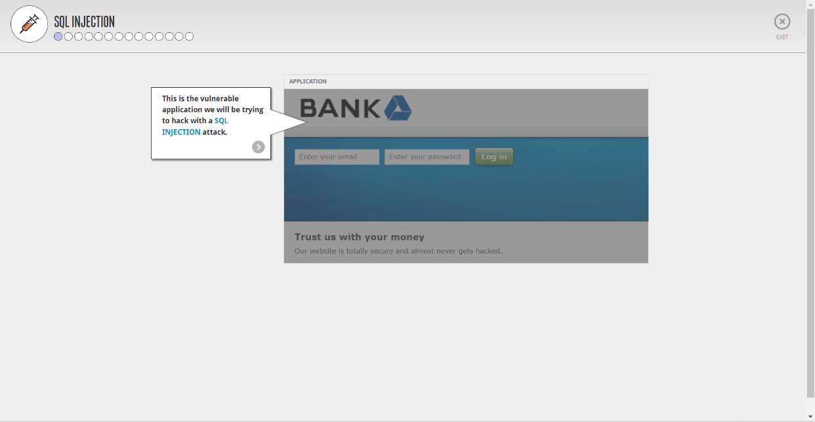
5. You can also see the application log window which shows all the details entered in the web page.

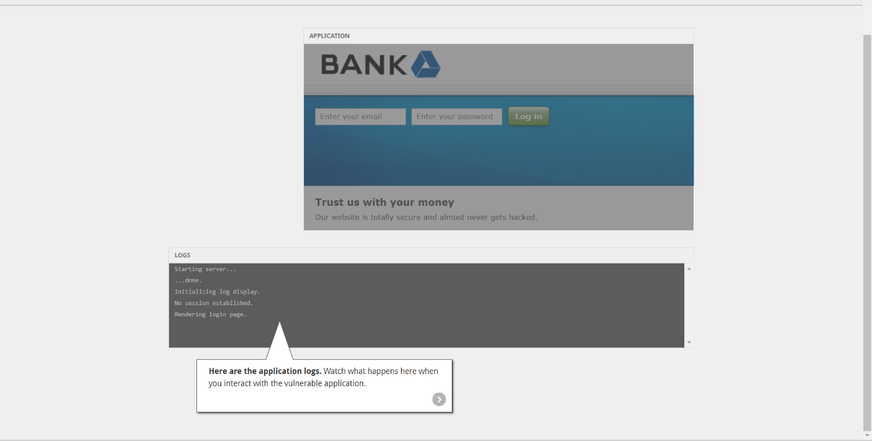

1. Try entering Username as [username@email.com](mailto:username@email.com) and password as password ‘.
2. Since the password is incorrect you can see that log window shows that there is an SQL syntax error.
3. 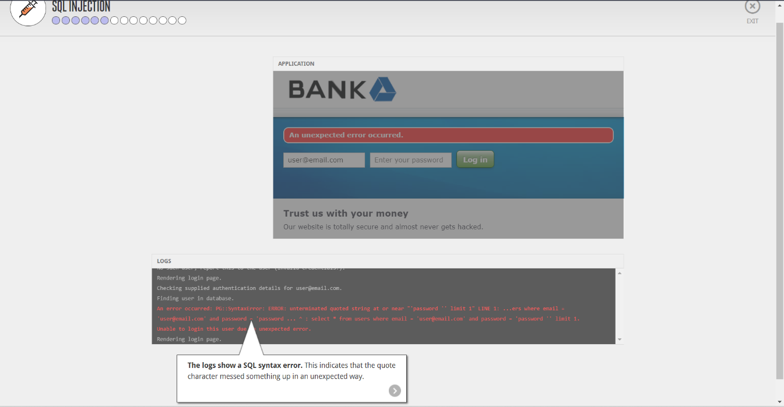
4. Below image shows a new section called Code which shows that the user name and password you enter directly goes into the SQL query.
5. 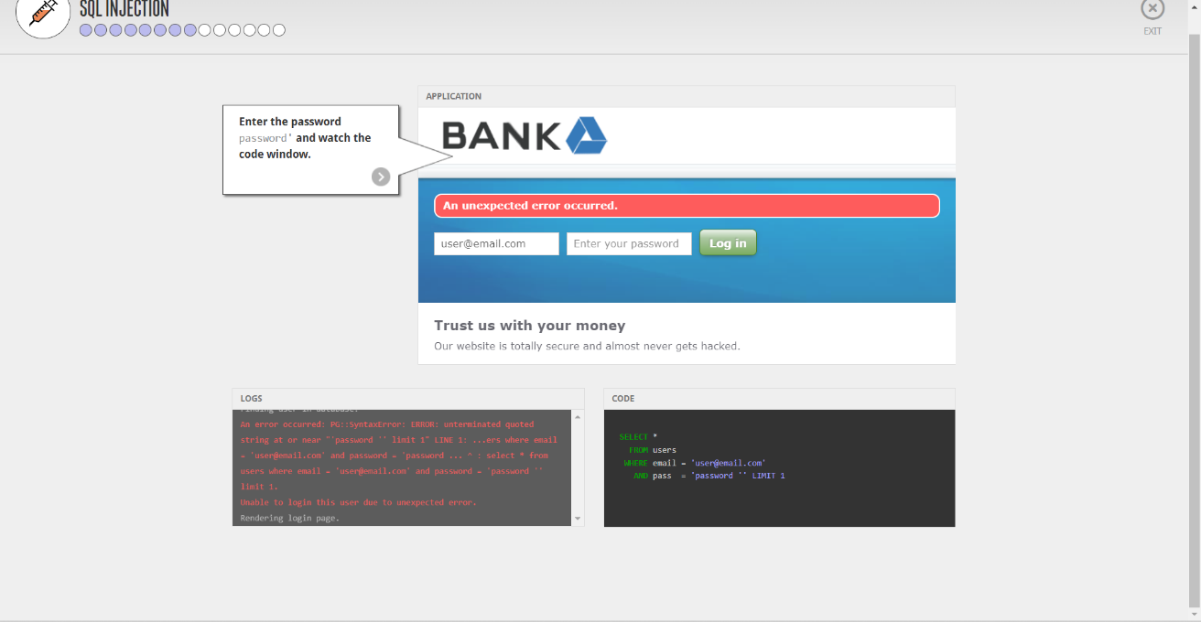
6. This behaviour shows that the application might be vulnerable to SQL Injection.

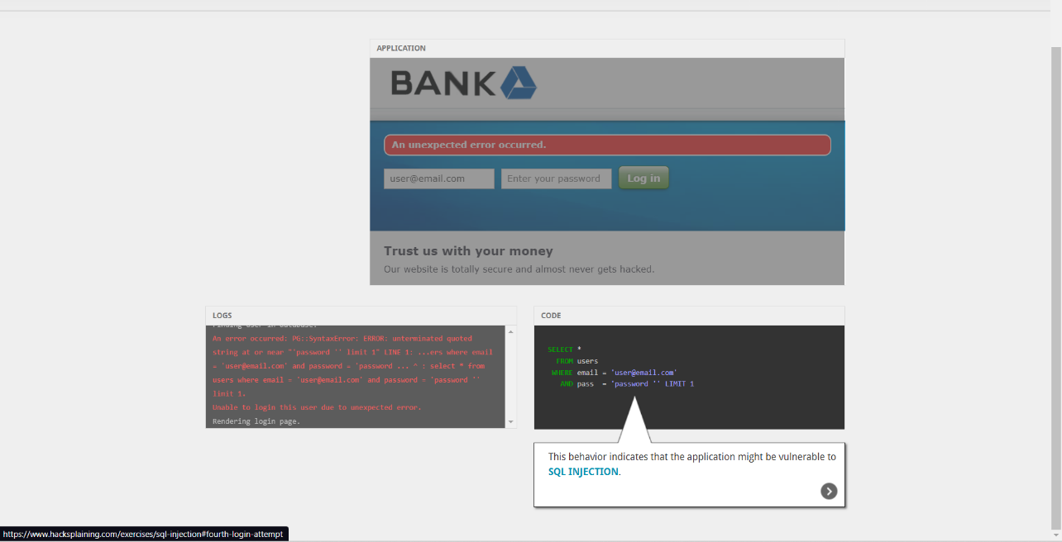

1. Now try entering username and password as below.
2. Output:

Voila, we have successfully done SQL Injection. Below are the bank details

1. 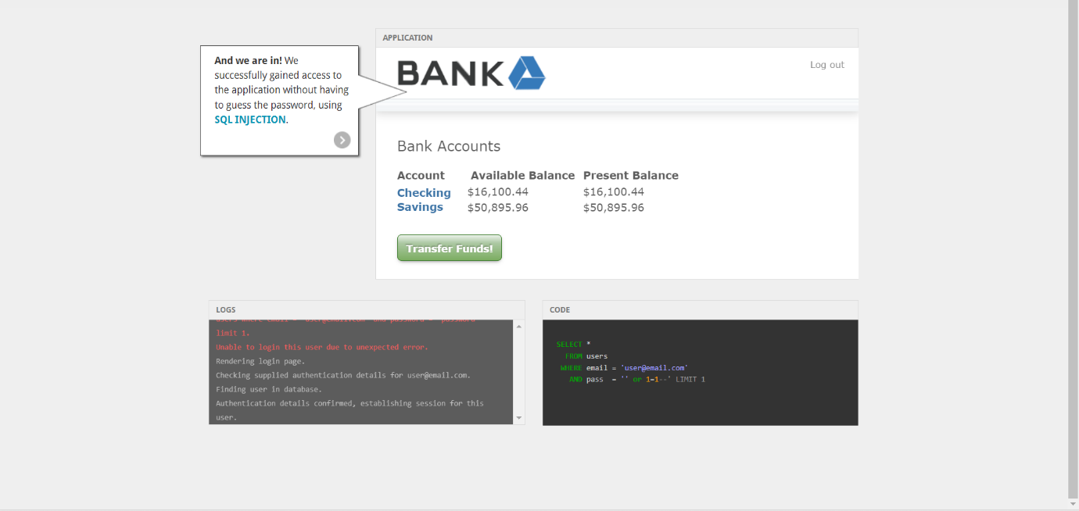

----END---